

GLOBODIET
RECIPE MANAGER
DATA EXPORT
Appendix 8: November 2015
Dietary Exposure Assessment Group (DEX)
International Agency for Research on Cancer (IARC)

Summary

- Introduction 03
- Description of MIXEDREC worksheet 04
- Description of MIXEDING worksheet 05
- Description of MIXEDING_QT worksheet 06
- Linkage between ingredients in MIXEDING worksheet 07

Introduction

The RECIPE MANAGER has been developed to facilitate the management of the recipe part of GloboDiet outside the field work.
The country coordinator has the task to enter recipes following the GloboDiet methodology tips provided in the User’s manual called “RecipeManager-User_Manual_Nov2014.doc”
Before entering recipes, definitions and guidelines concerning mixed and composed recipes should be reviewed carefully and understood (see “RecipeManager-User_Manual_Nov2014.doc”).
A specific training course on the RECIPE MANAGER application is also available at IARC.

The aim of this guideline is to describe the Excel recipe file exported from the Recipe Manager application. These file formats are fixed and standardized whatever the project.
You can find here, the dictionary of these variables per exported files as the way to selected specific lines/records and links between records/lines.

The Recipe Manager application allows to:
- Export recipes generating a xml-file
- Import recipes reading the a xml-file
- Export recipes generation a xls-file

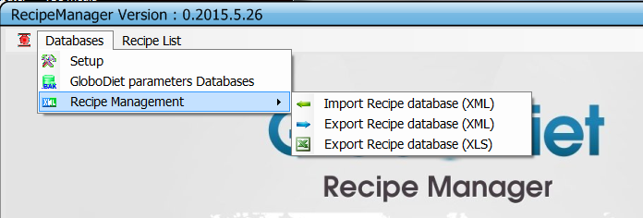

The function “Export Recipe database (XLS)”, allows the user to generate an Excel recipe file to a destination folder:
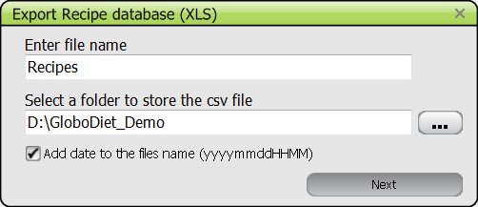

NOTE:
- The recipes and attached ingredients have to be entered / centralised in one PC.
- The export file (Excel or XML-file) has to be sent to IARC to be included in the GloboDiet database.
- If these recipe data are used for linkage with food composition table, you have to export them in both format xls- and xml-file; the xml-file allowing importing them in GloboDiet database when needed and the xls-file allowing communication with other applications.
All the information related to the entered recipes and its attached ingredients are available in 3 different worksheets of the Excel file.

This document describes the content of the 3 available worksheets giving name, label and format of each variable. These 3 worksheets are:

- MIXEDREC: Worksheet relative to information on the recipe.

- MIXEDING: Worksheet relative to information on the attached ingredients.

- MIXEDING_QT: Worksheet relative to two specific quantification methods for ingredients that are photo and shape methods for which several servings can be selected

At the end of the document, you can find examples of links between some ingredients.

Description of MIXEDREC worksheet

This file contains general information on the recipe (e.g. ID, name…).
In this table, we will have one line/record per recipe.

Name | Label | Format
R_IDNUM | Recipe code | Char | 5
R_GROUP | Recipe group code | Char | 2
R_SUBGROUP | Recipe sub-group code | Char | 2
R_NAME | Recipe name | Char | 100
R_TYPE | Type of recipe:  1.1=Open – Known  1.2=Open – Unknown  1.3=Open with brand  2.1=Closed  2.2=Closed with brand  3.0=Commercial  4.1=New – Known  4.2=New – Unknown | Char | 3
R_BRAND | Brand name for commercial recipe | Char | 100
TYPE | Recipe type SH=Shadow or blank | Char | 2
R_SUB | 0=recipe without sub-recipe  1=recipe with sub-recipe | Num | 1
STATUS | Recipe status: 1=finalised, 3=to be complited | Num | 1

Description of MIXEDING worksheet (1/2)

This file contains information on the reported ingredients (e.g. description and quantification)
In this file, we have several lines/records per recipe and this number of lines depends on the number of reported ingredients per recipe.

Name | Label | Format
R_IDNUM | Recipe ID number the ingredient belong to | Char | 5
ING_NUM | Sequential Number for Ingredients within a Mixed Recipe | Float
ING_TYPE | Ingredient type:  1=Fixed  2=Substitutable  3=Fat during cooking (attached to deep fried ingredient)  A2=Type of fat used  A3=Type of milk/liquid used | Char | 2
TYPE | Ingredient Generic (GI= or not (blank) | Char | 2
IDNUM | Ingredient Food ID number | Char | 5
GROUP | Ingredient food group | Char | 2
SUBGROUP1 | Ingredient food subgroup | Char | 2
SUBGROUP2 | Ingredient food sub-subgroup | Char | 2
NAME | Ingredient name | Char | 100
TEXT | Description text (facet/descriptor text) | Char | 255
FACETS_STR | Facets-Descriptors codes used to describe the ingredient | Char | 255
BRANDNAME | Ingredient brand name (if any) | Char | 100
STATUS | =1 if ingredient described and quantified else =2 | Char | 1
CONS_QTY | Final quantity in g (with coefficient applied) | Float
Q_METHOD | Type of quantification method | Char | 1
QM_CODE | Quantification method code | Char | 4
ESTIM_QTY | Estimated quantity (before coefficient applied) | Float
NGRAMS | Quantity in gr/volume attached to the selected Photo, HHM, STDU | Float
PROPORT | Proportion of Photo, HHM, STDU | Char | 5
HHMFRACT | HHM Fraction | Char | 5
RAWCOOKED | Quantity Estimated Raw or Cooked:  1 = Raw 2 = Cooked or Not applicable | Char | 1
CONSRAWCO | Quantity Consumed Raw or Cooked:  1 = Raw 2 = Cooked or Not applicable | Char | 1
CONVER | Conversion factor raw->cook | Float
EDIB | Quantity as estimated:  1=without un-edible part & 2=with un-edible part | Char | 1
EDIB_CSTE | Conversion factor for edible part | Float
DENSITY | Density Coefficient only for HHM | Float
PCT_CONS | Percentage/Proportion as Consumed for Recipe Ingredients | Float
PCT_ESTIM | Percentage/Proportion as Estimated for Recipe Ingredients | Float
Q_UNIT | Unit of selected quantity for method Photo, std U, std P (G=gram, V=volume) | Char | 1
RAW_Q | Raw quantity without inedible | Float

Description of MIXEDING worksheet (2/2)

Name | Label | Format
TYPE_IT | Type of item: 1 for food, 2 for recipe always food today | Num | 1
S_ING_NUM | Sequential Number for Ingredients within a Sub-Recipe (Not applicable today) | Float
FATL_PCT | Fat Left-Over Percentage | Float
FATLEFTO | Fat Left-Over Code (F=False, T=True) | Float
POUND | Consumed quantity in pound | Float
OUNCE | Consumed quantity in ounce | Float
QUART | Consumed quantity in quart | Float
PINT | Consumed quantity in pint | Float
FLOUNCE | Consumed quantity in flounce | Float

(⁺) In the FACETS_STR variable, 4 additional codes are available:
- 1201 is used when a brand or product name has been entered (new brand) during the interview.
- 1299 is used when a brand or product name has been selected from the available list.
- 1501 is used when one or several fats have been selected during the interview to describe the food/ingredient. This fat information is available in INTERV file as record(s) attached to the described food/ingredient with TYPE=’A2’. See p16 part g.
- 1601 is used when one or several liquids have been selected during the interview to describe the food/ingredient. This liquid information is available in INTERV file as record(s) attached to the described food/ingredient with TYPE=’A3’. See p16 part g.

Description of MIXEDING_QT worksheet

This file contains information on two specific quantification methods that are photo and shape methods for which several servings can be selected.
In this file, we can have several lines/records per recipe ingredients quantified with photo or shape method. For example, a reported ingredient quantified with 2 shapes has 2 lines available in this worksheet.
Note: This file is not available when these two methods have not been selected for recipe ingredient.

Name | Label | Format
R_IDNUM | Recipe ID number the ingredient belong to | Char | 5
FOODNUM | Ingredient Food ID number | Char | 5
ING_NUM | Sequential Number within a Mixed Recipe for Ingr. | Float
ORDER | Order of shape selection (e.g. 1) | Num | 5
SH_CODE | Shape code (e.g. S001) | Char | 5
SH_SURFACE | Shape surface in cm2 (e.g. 200cm2). 2 decimals | Float
TH_CODE | Shape: Thickness code (e.g. A or 58_1) | Char | 10
TH_THICK | Thickness in mm (e.g. 40mm, 0.05 mm). 5 decimals | Float
PH_CODE | Photo: Number of the Selected Photo (e.g. 1 or 4) | Char | 4
PH_QTY | Photo quantity | Float
FRACT | Shape & Photo: Fraction or unit (e.g. 3/5 or 1 or 2) | Char | 5
S_ING_NUM | Sequential Number for Ingredients within a Sub-Recipe (Not applicable today) | Float

–Linkage between ingredients in MIXEDING worksheet

It is possible to identify the links between:
- A deep fried ingredient and its attached fat(s)
- An ingredient described with the facet “type of fat used” (coded 15) and its attached fat(s)
- An ingredient described with the facet “type of liquid used” (coded 16) and its attached liquid(s)

The ingredient type ING_TYPE and ingredient number ING_NUM variables allow you to identify these links.

The ingredient type is called ING_TYPE defines the ingredient with the modalities:
  - 1 : Fixed ingredient that cannot be modified during the interview
  - 2: Substitutable ingredient that can be modified during the interview
  - 3 : Fat during cooking attached to deep fried ingredient
  - A2 : Answer of Type of Fat used facet coded 15 – qualitative info.
  - A3 : Answer of Type of liquid used facet coded 16 – qualitative info.

The ingredient type is called ING_NUM is a sequential number within the recipe (e.g. from 1 to 10 if 10 available ingredient for a recipe).
Within a recipe, 2 ingredients can have the same ING_NUM for:
- A deep fried ingredient (described with descriptor 03….) and its attached fat(s) coded with ING_TYPE=3. Deep fried ingredients are described with the descriptors:
  - 03 08 fried in pan/deep fried with fat n.s.
  - 03 10 deep fried
  - 03 18 breaded and fried/deep fried n.s.
  - 03 24 battered and deep fried
  - 03 52 breaded and deep fried
  - 03 56 in flour and deep fried
- an ingredient described with the facet “type of fat used” (coded 15) and its attached fat(s) coded with ING_TYPE=A2
- An ingredient described with the facet “type of liquid used” (coded 16) and its attached liquid(s) coded with ING_TYPE=A3

Case 1: Link between a deep fried ingredient and its attached fat(s):

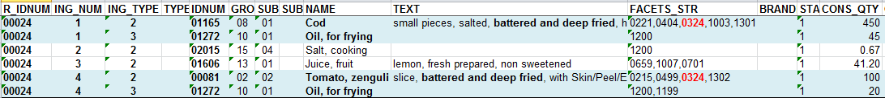

For the recipe coded ‘00024’, 6 ingredients are available.

The ingredients ‘Cod’ and ‘Oil, for frying’ are linked:
- They have the same ING_NUM (=1 for both).
- ‘Cod’ is consumed as ‘battered and deep fried’ (descriptor ‘0324’ available in FACETS_STR)
- ‘Oil, for frying’ is the fat attached to ‘Cod’ because is defined with ING_TYPE=3 (as Fat during cooking)

The ingredients ‘Tomato, zenguli’ and ‘Oil, for frying’ are linked:
- They have the same ING_NUM (=4 for both).
- ‘Tomato, zenguli’ is consumed as ‘battered and deep fried’ (descriptor ‘0324’ available in FACETS_STR)
- ‘Oil, for frying’ is the fat attached to ‘Tomato, zenguli’ because is defined with ING_TYPE=3 (as Fat during cooking)

Note: Several Fats can be attached to an ingredient. These fats will be defined with ING_TYPE=3 and will have the same ING_NUM value as the attached ingredient.

Case 2: Link between an ingredient that is described with the facet “type of fat used” and its attached fat(s):

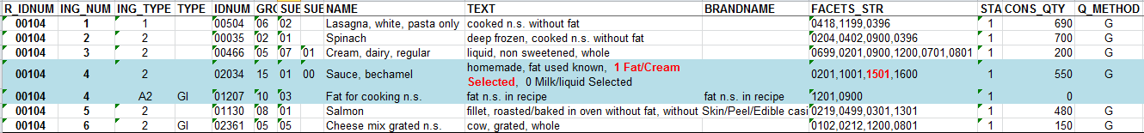

For the recipe coded ‘00104’, 7 ingredients are available.

The ingredients ‘Sauce, bechamel’ and ‘Fat for cooking n.s.’ are linked:
- They have the same ING_NUM (=4 for both).
- ‘Sauce, bechamel’ is described with ‘1 Fat/Cream selected’ (descriptor ‘1501’ available in FACETS_STR)
- ‘Fat for cooking n.s.’ is the fat attached to ‘Sauce, Bechamel’ because is defined with ING_TYPE=A2 (as “type of fat used”)

Note: Several fats can be attached to an ingredient. These fats will be defined with ING_TYPE=A2 and will have the same ING_NUM value as the attached ingredient.

Case 3: Link between an ingredient that is described with the facet “type of liquid used” and its attached fat(s):

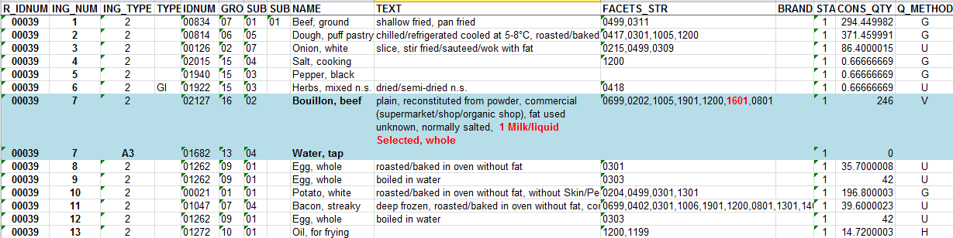

For the recipe coded ‘00039’, 14 ingredients are available.

The ingredients ‘Bouillon, beef’ and ‘Water, tap’ are linked:
- They have the same ING_NUM (=7 for both).
- ‘Bouillon, beef’ is described with ‘1 milk/liquid selected’ (descriptor ‘1601’ available in FACETS_STR)
- ‘Water, tap’ is the liquid attached to ‘Bouillon, beef’ because is defined with ING_TYPE=A3 (as “type of liquid used”)

Note: Several Liquids can be attached to an ingredient. These liquids will be defined with ING_TYPE=A3 and will have the same ING_NUM value as the attached ingredient.

Case 4: Link between an ingredient that is described with the facets “type of liquid used” and with the facet “type of fat used” and its attached fat(s) and liquid(s):

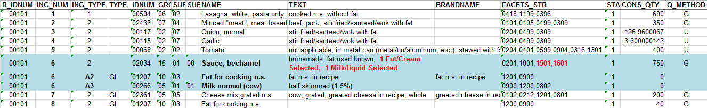

For the recipe coded ‘00101’, 10 ingredients are available.

The ingredients ‘Sauce, bechamel’ is linked with ‘Fat for cooking n.s.’ and with ‘Milk normal’
- They have the same ING_NUM (=6 for all).
- ‘Sauce, bechamel’ is described with ‘1 Fat/Cream selected’ and with ‘1 liquid used’ (descriptors ‘1501’ & ‘1601’ available in FACETS_STR)
- ‘Fat for cooking n.s.’ is the fat attached to ‘Sauce, Bechamel’ because is defined with ING_TYPE=A2 (as “type of fat used”)
- ‘Milk normal’ is the liquid attached to ‘Sauce, bechamel’ because is defined with ING_TYPE=A3 (as “type of liquid used”)

Note: Several fats and liquids can be attached to an ingredient. These fats will be defined with ING_TYPE=A2, these liquids will be defined with ING_TYPE=A3 and all will have the same ING_NUM value as the attached ingredient.

